Name: _______________________________________________
Foundation Unit 5b topic test
Date:
Time: 45 minutes
Total marks available: 43
Total marks achieved: ______

Questions
Q1.
Here is a sequence of patterns made with counters.
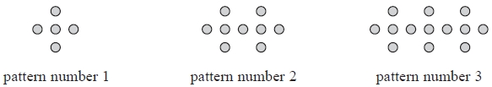
(a) In the space below, draw pattern number 4
(1)
(b) Complete the table.
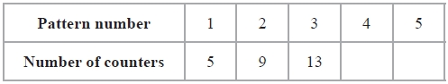
(1)
(c) Find an expression, in terms of n, for the number of counters in pattern number n.
...........................................................
(2)
Habeeb has 50 counters.
He wants to use as many of his counters as possible to make a pattern in the sequence.
(d) What is the number of the pattern he can make using the greatest number of his counters?
...........................................................
(2)
(Total for Question is 6 marks)
Q2.
Here are some patterns made from triangles.
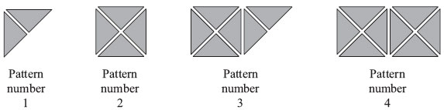
(a) Complete the table.
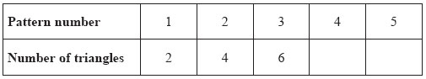
(1)
(b) How many triangles are needed for Pattern number 12?

..............................................................................................................................................
(1)
Luke says that Pattern number 40 has 82 triangles.
(c) Luke is wrong.
Explain why.
..............................................................................................................................................
..............................................................................................................................................
(1)
(Total for Question is 3 marks)

Q3.
Here are the first three patterns in a sequence.
The patterns are made from triangles and rectangles.
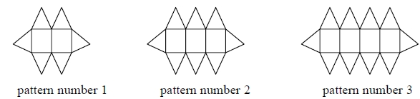
(a) How many triangles are there in pattern number 7?
...........................................................
(2)
Charlie says
"There are 4 rectangles in pattern number 3 so there will be 8 rectangles in pattern number 6"
(b) Is Charlie right?
Give a reason for your answer.
.............................................................................................................................................
.............................................................................................................................................
(1)
(Total for question = 3 marks)

Q4.
Here are the first four terms of a number sequence.
6 | 10 | 14 | 18

(a) Write down the next term in this sequence.

..............................................................................................................................................
(1)
(b) Find the 10th term in this sequence.

..............................................................................................................................................
(1)
(c) The number 101 is not a term in this sequence.
Explain why.
..............................................................................................................................................
..............................................................................................................................................
(1)
(d) Write an expression, in terms of n, for the nth term of this sequence.

..............................................................................................................................................
(2)
(Total for Question is 5 marks)

Q5.
Here are the first four terms of a number sequence.
3 7 11 15
(a) Write down the next term of this sequence.
...........................................................
(1)
The 50th term of this number sequence is 199
(b) Write down the 51st term of this sequence.
...........................................................
(1)
The number 372 is not a term of this sequence.
(c) Explain why.
.............................................................................................................................................
.............................................................................................................................................
(1)
(Total for Question is 3 marks)

Q6.
Here are the first four terms of a number sequence.
4 | 7 | 10 | 13
(a) (i) What is the next term in the sequence?

..............................................................................................................................................
(ii) Explain how you found your answer.

..............................................................................................................................................
(2)
(b) What is the 8th term in the sequence?

..............................................................................................................................................
(1)
Alexi says 34 is in the sequence.
(c) Is Alexi correct? . . . . . . . . . . . . . . . . . . . . . .
You must give a reason for your answer.

..............................................................................................................................................
(1)
(Total for Question is 4 marks)

Q7.
Here are the first five terms of an arithmetic sequence.
2 | 7 | 12 | 17 | 22
(a) (i) Find the next term of this sequence.
..............................................................................................................................................
(ii) Explain how you found your answer.
..............................................................................................................................................
..............................................................................................................................................
(2)
(b) Write down an expression, in terms of n, for the nth term of the sequence.

..............................................................................................................................................
(2)
(Total for Question is 4 marks)
Q8.
Here are the first four terms of an arithmetic sequence.
6 10 14 18
(a) Write an expression, in terms of n, for the nth term of this sequence.
...........................................................
(2)
The nth term of a different arithmetic sequence is 3n + 5
(b) Is 108 a term of this sequence?
Show how you get your answer.
(2)

(Total for question = 4 marks)

Q9.
Here are the first six terms of a Fibonacci sequence.
1 1 2 3 5 8
The rule to continue a Fibonacci sequence is,
the next term in the sequence is the sum of the two previous terms.
(a) Find the 9th term of this sequence.
...........................................................
(1)
The first three terms of a different Fibonacci sequence are
a b a + b
(b) Show that the 6th term of this sequence is 3a + 5b
(2)
Given that the 3rd term is 7 and the 6th term is 29,
(c) find the value of a and the value of b.
a = ...........................................................
b = ...........................................................
(3)
(Total for question = 6 marks)

Q10.
(a) Write down the 20th odd number.
(1)
The sum of two consecutive odd numbers is 48
(b) Find the smaller of these two odd numbers.
(2)
Here are the first five terms of an arithmetic sequence.
5 8 11 14 17
(c) Is 42 a term of this sequence?
Show how you get your answer.
(2)

(Total for question = 5 marks)

Examiner's Report
Q1.
In part (a) most students were able to replicate the pattern. Incorrect responses generally showed the first pattern repeated 5 times, resulting in the additional dot being repeated an extra 4 times. Part (b) was also very successfully answered with most students gaining the mark.
In part (c) the most common incorrect responses did involve some use of the term to term difference of + 4 but frequently this was seen as n + 4. The students who had presented the correct nth term expression in part (c) generally went on to use it correctly to answer part (d). Other correct answers often came from a clear continuation of the sequence or a diagram showing pattern number 12. Many students used multiples of values in the table incorrectly, typically deducing that pattern 10 would have 42 dots as pattern 5 had 21.

Q2.
This was very well answered with the majority gaining the full 3 marks. There were very few errors in parts (a) and (b); if marks were lost, it was usually for a poor explanation offered in part (c). 'It goes up in 2s' or '82 is not in the 2 times table' were not uncommon incorrect explanations. Quite a number of responses demonstrated logic that would have been incorrect if the sequence had been 2n + anything other than zero.

Q3.
No Examiner's Report available for this question

Q4.
Parts (a) and (b) were very well answered with the vast majority of candidates able to identify the next and 10th term in the linear sequence. The most common misconception in part (b) was to double the 5th term 22 from part (a) to give 44 rather than 42.Three quarters of the candidates were able to gain at least one mark for parts (c) and (d) and usually did so with a correct explanation in part (c) Answers referring to 101 being odd and/or the terms in the sequence being even were most common with some excellent answers with statements well justified using numerical examples. A common error was to assume that the sequence was multiples of 4 as it had a term-to-term difference of 4.
In part (d) many candidates correctly identified the need for 4n in the term, but few were able to complete it successfully. Others reversed the 2 and 4 in the rule to give 2n+4 and many gave the term-to-term rule of n+4 instead.

Q5.
Part (a) was answered usually correct.
Part (b) was well answered, very few blank or incorrect responses were seen.
In Part (c), whilst only a minimal reason was required, many lacked clarity. Common incorrect responses seen were "it goes up in 4s" "not in the four times table" "it's not in the pattern". Correct answers usually referred to the sequence consisting of odd numbers or the fact that 372 was even, or both points and some candidates correctly used the nth term. However, a few candidates did confuse the terms odd and even.

Q6.
98% of candidates scored at least 1 mark on part (a) with nearly 90% scoring both available with an explanation of how the next term could be found. In order to score the second mark it was important for candidates to not only mention the term to term difference of 3 but also note that the sequence was increasing and so 3 needed to be added. Some candidates gave the correct nth term rule 3n + 1 instead.
75% of candidates gave the correct 8th term of the sequence in part (b). The most common errors involved giving the 9th term 28 or 24 from 8 × 3. 50% of candidates gave a correct explanation in part (c) with incorrect answers referring only to multiples of 3 or the alternating odd and even terms of the sequence.

Q7.
Part (a)(i) of this question was well answered with very few incorrect responses seen. Some candidates wrote additional terms in the sequence 27, 32, etc but provided they were correct this did not stop them achieving B1, of course a few did offer additional incorrect answers and achieved B0.
Part (a)(ii) was well attempted by candidates with candidates correctly offering +5, add 5, increases by 5, however, many candidates offered ambiguous answers such as stating the difference without indicating whether it should be added or subtracted, hence B0. Likewise others referred to a gap of 5. Some of the more able candidates quoted 5n-3 which was awarded B1. A common incorrect response was to comment on the units digit alternating between 2 and 7
Part (b) of this question was also well attempted by candidates but frequently the weaker candidates worked out further terms or wrote n + 5 and gained no marks. Some correctly wrote 5n realising a link to the five times table but only achieved B1. Common incorrect responses included 2n and 3n.

Q8.
No Examiner's Report available for this question

Q9.
No Examiner's Report available for this question

Q10.
No Examiner's Report available for this question

Mark Scheme
Q1.
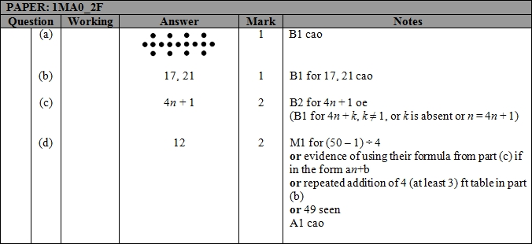

Q2.
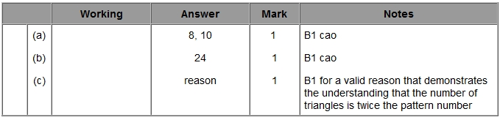

Q3.
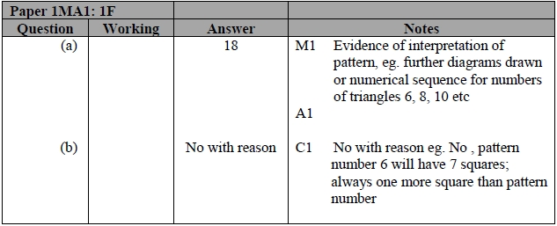

Q4.
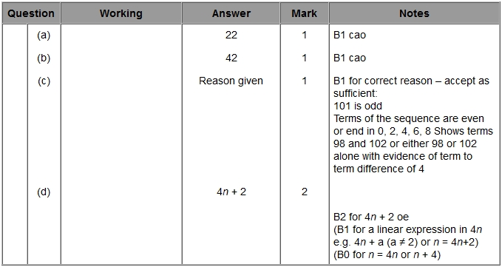

Q5.
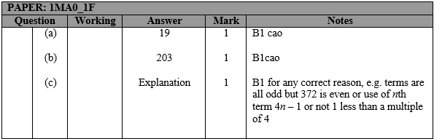

Q6.
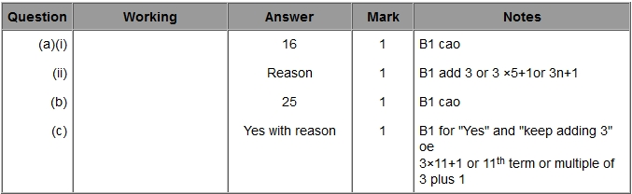
Q7.
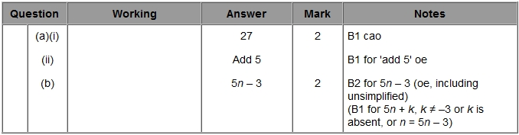

Q8.
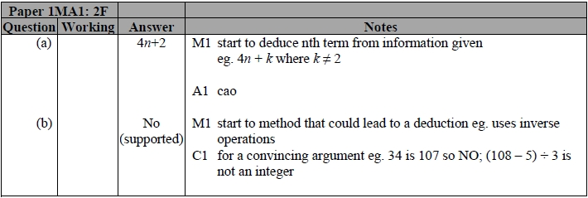

Q9.
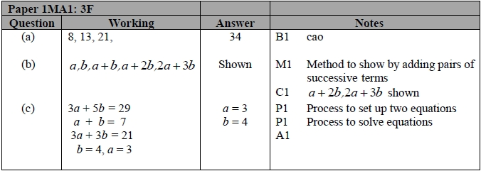

Q10.
